

The HL7 Comprehensive Database

Active Server Pages facilitating PHP

Author: Frank Oemig

|  |  |
| --- | --- |
| email: | HL7@Oemig.de |
| Current Status: | in progress |
| DB-File: | HL7_92.mdb |
| Date: | 10.01.2017 |

Contents Page

The HL7 Comprehensive Database 1

Active Server Pages facilitating PHP 1

1. Introduction 3

1.1. Requirements 3

2. Installation of XAMPP 4

2.1. Adjust configuration file 4

2.2. Start server 4

2.3. Call script 5

3. Additional Information 7

3.1. General layout of scripts 7

3.2. Styles 7

4. Appendix 9

4.1. Installation of Apache + PHP (outdated) 9

4.1.1. Installation Steps 9

4.1.2. Adapt Configuration of Apache 9

4.1.3. Testing 9

4.1.4. Adapt Configuration of IIS 10

4.1.5. Additional Configuration in the database 10

4.2. PHP files 10

# Introduction

The HL7 database should be accessed directly by the help of a webserver in combination with some scripts. One possible solution is a set of scripts using PHP running on an Apache Web Server. The usage should be described within this document.

## Requirements

* Apache Web Server
* PHP
* Internet Browser
* The HL7 database

The first two requirements can be fulfilled by installing XAMPP.

# Installation of XAMPP

A better way to install Apache and PHP scripting is to download the XAMPP project. It provides Apache, PHP, mySWL, and Tomcat:

<https://www.apachefriends.org>

It allows for different types of installation, either as a ZIP file or via a normal installer. What you are choosing depends on you.

After successful installation additional configuration must be done:

## Adjust configuration file

The following file needs additional entries:

C:\xampp\apache\conf\httpd.conf

You have to add below DocumentsRoot a new entry pointing to where you have stored the PHP scripts.

DocumentRoot "C:/xampp/htdocs"

#fox:new entry

Alias "/HL7_dynamic" "D:/Eigene Dateien/Daten/php"

Furthermore, you have to declare this new directory just behind the other **Directory** entries:

<Directory "D:/Eigene Dateien/Daten/php">

Options Indexes FollowSymLinks Includes ExecCGI

AllowOverride None

Order allow,deny

Allow from all

</Directory>

## Start server

Now you can start the Apache server. You will find it in the start section of Windows:

XAMPP Control Panel:

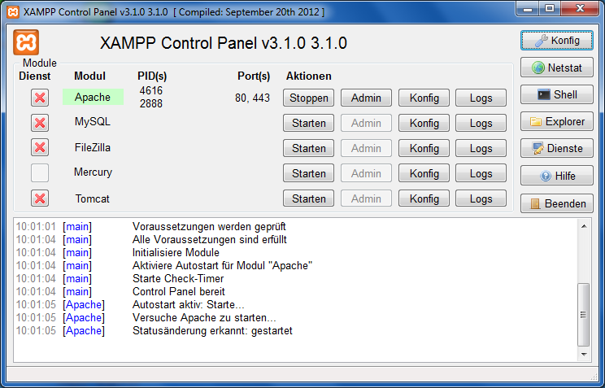

The Apache Module should be shown with a green background.

## Call script

The next step is to access the PHP scripts. In case you have copied them into the above folder you should try the following link:

http://localhost/HL7_dynamic/hl7.php

It is probably a good idea to add this link to the page coming up when calling localhost only.

If it responds like the following the scripts are working from an Apache perspective:



Clicking into the image should result in a list of available versions:

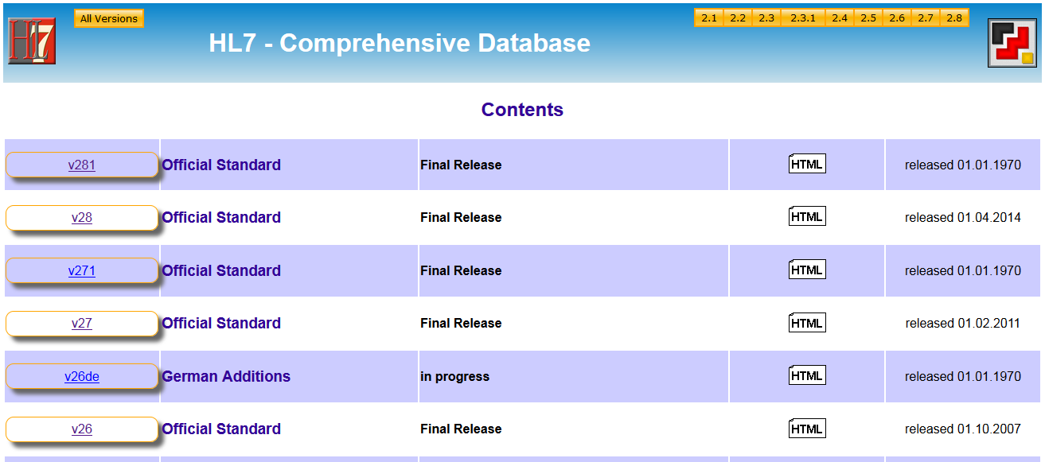

If not, you need to adapt the db.php file because the link to the database file is wrong:

$mdbFilename="D:/Eigene Dateien/HL7/Datenbank/hl7_73.mdb";

Please correct the link to the file.

# Additional Information

## General layout of scripts

The general structure of the scripts is quite simple:

open database

collect information about the required version (hl7_vinfo.php)

generate header (hl7_header.php)

generate buttons (hl7_buttons.php)

if no special information is required (e.g. event)

generate list

else

generate specific information

end if

generate footer

## Styles

The PHP scripts as well as the generated HTML documentation take advantage of the style sheet functionality. Therefore, the general layout of the HTML files can be influenced by changing the style sheet. The one provided with this software is "formate.css".

| Element | Comment |
| --- | --- |
| body {  background-image:url(images/background.gif);  background-color:"#CCCCCC";  text:"#000000";  link:"#FF0000";  vlink:"#666666";  alink:"#CC9900"  } | normal body text |
| p,dd,pre { font-family:"helvetica"}  h1 { font-family:"helvetica"; color:"#2200DD" }  h2 { font-family:"helvetica"; color:"#330099" }  h3 { font-family:"helvetica"; color:"#330099" }  a:link { font-family:"helvetica"; color:blue }  UL,LI,BLOCKQUOTE { font-family:"helvetica"} | normal paragraphs |
| pre { letter-spacing:3px; } | message structures  (for correct indentation) |
| table { font-family:"helvetica"} | normal tables |
| table.nav {  border-color:blue;  border-style:double;  padding: 0px;  spacing:0px;  }  th.nav, td.nav { /* ns 4 */  font-family: Arial, Helvetica, sans-serif;  font-size: 14px;  xtext-align: justify;  text-align: center;  font-weight: bold;  }  th.nav {  border-bottom: 1px solid blue;  } | navigation tables  (header) |
| table.info {  border-color:grey;  border-width:2px;  border-style:outset;  }  th.info {  background-color: silver;  text-align: center;  font-weight: bold;  }  td.info { /* ns 4 */  xfont-family: Arial, Helvetica, sans-serif;  xfont-size: 14px;  xtext-align: justify;  text-align: left;  xfont-weight: bold;  border-width:1px;  border-style:inset;  } | information tables  (main part) |
| hr {  width:60%;  height: 6px;  background-color: #888888;  } | horizontal ruler |

# Appendix

## Installation of Apache + PHP (outdated)

This is an outdated description when trying to install Apache and PHP separately.

### Installation Steps

1. Installation of Apache 2.0.45 (follow installation)
2. Installation of PHP 4.3.1 (extract files from zip file to "C:/<program files>") or 5.0 (extract files from zip file to "C:/<program files>/PHP5.0")
3. adjust configuration to run PHP and to find files
4. copy the ini-file of PHP ("php.ini-recommended" to "php.ini" in the windows system directory)
5. adjust php.ini (set doc_root to the appropriate directory)
6. copy PHP scripts to desired directory
7. define this database as “HL7” in the system DSN of the ODBC configuration
8. introduce the starting page of the PHP scripts into one of the pages of Apache

### Adapt Configuration of Apache

Some manual corrections are required to the configuration file of Apache in order to access our PHP scripts.

Please add the following lines to "http.conf" in the "conf" subdirectory of the Apache 2 installation:

To find the own files. "/own_files/" should correspond to the relative path information used as link to the PHP scripts. The target should define where the files are located (in combination with the path expression used in the link):

Alias /own_files/ "D:/Own Files/"

Define, where Apache can find the PHP executables:

for PHP 4.x

ScriptAlias /php/ "C:/<Program Files>/php-4.3.1-Win32/"

AddType application/x-httpd-php .php .phtm

Action application/x-httpd-php "/php/php.exe"

or for PHP 5.0

Action application/x-httpd-php "/php/php-cgi.exe"

After modifying the configuration restart the Apache service.

### Testing

Create a file named "info.php" with the following contents:

<?php

phpinfo();

?>

Open this file with Internet Explorer or Firefox.

### Adapt Configuration of IIS

There has been some trying to use the Microsoft Internet Information Server as a webserver as well. It turned out, that there is no easy way in configuring it to make PHP scripting running. Therefore, this description has been worked out for Apache only.

### Additional Configuration in the database

The database provides additional configuration information in the table DBOptions. Option #18 specifies the (relative) path to the standard HTML files to gain access to the original documents in their HTML form.

## PHP files

The following files are provided with the PHP functionality. Copy them

| File | Type | Contents | Parameters | supplementary? |
| --- | --- | --- | --- | --- |
| hl7 | PHP | Starting page |  |  |
| hl7_buttons | PHP | generates the required buttons  (operates on general variables) |  | yes |
| hl7_confstat | PHP | infos about conformance statements | vVersion  vConfStat |  |
| hl7_contents | PHP | infos about available versions |  |  |
| hl7_dataelem | PHP | infos about data elements | vVersion  vDatat |  |
| hl7_datastruct | PHP | infos about data structures | vVersion  vStruct |  |
| hl7_datatype | PHP | infos about data types | vVersion  vType |  |
| hl7_event | PHP | infos about events | vVersion  vEvent |  |
| hl7_footer | PHP | generates the footer |  | yes |
| hl7_header | PHP | generates the header (title with logo)  (operates on general variables) |  | yes |
| hl7_msgstruct | PHP | infos about message structures | vVersion  vStruct |  |
| hl7_msgtype | PHP | infos about message types | vVersion  vType |  |
| hl7_segment | PHP | infos about segments | vVersion  vSegment |  |
| hl7_sections | PHP | includes the sections of the standard for the given section | vVersion  vSection |  |
| hl7_table | PHP | infos about tabes | vVersion  vTable |  |
| hl7_version | PHP | infos about certain version | vVersion |  |
| hl7_vinfo | PHP | collects information about the required version from the database |  |  |
| formate | CSS | Stylesheet to format the pages |  |  |
| buttons | DOC | Word document with all buttons |  | yes |
| images/<pictures> | GIF  JPG | refer to the database documentation |  |  |